Design:Program1.aspx
<%@ Page Language="C#" AutoEventWireup="true" CodeFile="Program1.aspx.cs" Inherits="Program1" %>
<!DOCTYPE html>
<html>
<head>
<title>Program 1 - Exposure of Web Applications</title>
</head>
<body>
<form id="form1" runat="server">
<h2>Welcome to ASP.NET Web Application</h2>
<asp:Label ID="lblInfo" runat="server" Font-Size="Large"></asp:Label>
/form>
</body>
</html>

Source Code:Program1.aspx.cs
using System;
public partial class Program1 : System.Web.UI.Page
{
protected void Page_Load(object sender, EventArgs e)
{
lblInfo.Text = "This web application is running on: " + Request.Browser.Browser + " " + Request.Browser.Version + "<br />Server software: ASP.NET using Visual Studio 2019<br/>" +"Tools used: Visual Studio, .NET Framework, IIS Express.";
}
}

Design:Program2.aspx
<%@ Page Language="C#" AutoEventWireup="true" CodeFile="Program2.aspx.cs" Inherits="Program2" %>
<!DOCTYPE html>
<html>
<head><title>Program 2 - HTML Controls</title></head>
<body>
<form id="form1" runat="server">
<label for="name">Enter your name:</label>
<input type="text" name="name" />
<br /><br />
<input type="submit" value="Submit" />
</form>
</body>
</html>

Source Code:Program2.aspx.cs
using System;
public partial class Program2 : System.Web.UI.Page
{
protected void Page_Load(object sender, EventArgs e)
{
if (IsPostBack)
{
string name = Request.Form["name"];
Response.Write("Hello, " + name);
}
}
}

Design:Program3.aspx
<%@ Page Language="C#" AutoEventWireup="true" CodeFile="Program3.aspx.cs" Inherits="Program3" %>
<!DOCTYPE html>
<html>
<head runat="server">
<title>Program 3</title>
</head>
<body>
<form id="form1" runat="server">
<div>
<asp:TextBox ID="txtInput" runat="server" Placeholder="Enter Text"></asp:TextBox><br/><br />
<asp:Button ID="btnDisplay" runat="server" Text="Display" OnClick="btnDisplay_Click"/><br /><br />
<asp:Label ID="lblOutput" runat="server"></asp:Label>
</div>
</form>
</body>
</html>

Source Code:Program3.aspx.cs
using System;
public partial class Program3 : System.Web.UI.Page
{
protected void btnDisplay_Click(object sender, EventArgs e)
{
lblOutput.Text = "You entered: " + txtInput.Text;
}
}

Design:Program4.aspx
<%@ Page Language="C#" AutoEventWireup="true" CodeFile="Program4.aspx.cs" Inherits="Program4" %>
<!DOCTYPE html>
<html>
<head runat="server"><title>Program 4</title></head>
<body><form id="form1" runat="server">
<div>
<asp:DropDownList ID="ddlColors" runat="server">
<asp:ListItem Text="Red" Value="Red"></asp:ListItem>
<asp:ListItem Text="Green" Value="Green"></asp:ListItem>
<asp:ListItem Text="Blue" Value="Blue"></asp:ListItem>
</asp:DropDownList><br /><br />
<asp:CheckBox ID="chkBold" runat="server" Text="Bold" /><br/ > <br />
<asp:RadioButtonList ID="rblSize" runat="server">
<asp:ListItem Text="10" Value="10"></asp:ListItem>
<asp:ListItem Text="14" Value="14"></asp:ListItem>
<asp:ListItem Text="18" Value="18"></asp:ListItem>
</asp:RadioButtonList><br /><br />
<asp:Button ID="btnStyle" runat="server" Text="Apply Style" OnClick="btnStyle_Click" /><br /><br />
<asp:Label ID="lblStyledText" runat="server" Text="Sample Text"></asp:Label>
</div></form></body>
</html>

Source Code:Program4.aspx.cs
using System;
public partial class Program4 : System.Web.UI.Page
{
protected void btnStyle_Click(object sender, EventArgs e)
{
lblStyledText.ForeColor = System.Drawing.Color.FromName(ddlColors.SelectedValue); lblStyledText.Font.Bold = chkBold.Checked; lblStyledText.Font.Size = FontUnit.Point(Convert.ToInt32(rblSize.SelectedValue));
}
}

Design:Program5.aspx
<%@ Page Language="C#" AutoEventWireup="true" CodeFile="Program5.aspx.cs" Inherits="Program5" %>
<!DOCTYPE html>
<html>
<head runat="server"><title>Program 5</title> </head>
<body><form id="form1" runat="server">
<div>
<asp:ListBox ID="lstFruits" runat="server" SelectionMode="Multiple">
<asp:ListItem>Apple</asp:ListItem>
<asp:ListItem>Banana</asp:ListItem>
<asp:ListItem>Cherry</asp:ListItem>
</asp:ListBox><br /><br />
<asp:CheckBoxList ID="cblHobbies" runat="server">
<asp:ListItem>Reading</asp:ListItem>
<asp:ListItem>Traveling</asp:ListItem>
<asp:ListItem>Swimming</asp:ListItem>
</asp:CheckBoxList><br /><br />
<asp:Button ID="btnShowSelections" runat="server" Text="Show Selections" OnClick="btnShowSelections_Click" /><br /><br />
<asp:Label ID="lblSelections" runat="server"></asp:Label>
</div>
</form> </body> </html>

Source Code:Program5.aspx.cs
using System; using System.Text;
public partial class Program5 : System.Web.UI.Page
{
protected void btnShowSelections_Click(object sender, EventArgs e)
{
StringBuilder sb = new StringBuilder(); sb.Append("Fruits: "); foreach (System.Web.UI.WebControls.ListItem li in lstFruits.Items)
{if (li.Selected) sb.Append(li.Text + ", );}
sb.Append(" | Hobbies: ");
foreach (System.Web.UI.WebControls.ListItem li in cblHobbies.Items)
{if (li.Selected) sb.Append(li.Text + ", ");}
lblSelections.Text = sb.ToString();
}}

Design:Program6.aspx
<%@ Page Language="C#" AutoEventWireup="true" CodeFile="Program6.aspx.cs" Inherits="Program6" %>
<!DOCTYPE html>
<html>
<head runat="server"><title>Program 6</title></head>
<body><form id="form1" runat="server"><div>
<asp:Calendar ID="Calendar1" runat="server" OnSelectionChanged="Calendar1_SelectionChanged"></asp:Calendar><br /><br /> Select Date: <asp:TextBox ID="txtDate" runat="server" ReadOnly="True"></asp:TextBox><br /><br />
<asp:RequiredFieldValidator ControlToValidate="fuFile" ErrorMessage="Select a file" runat="server"></asp:RequiredFieldValidator><br /><br />
<asp:FileUpload ID="fuFile" runat="server" /><br /><br />
<asp:Button ID="btnSubmit" runat="server" Text="Submit" OnClick="btnSubmit_Click"/><br /><br />
<asp:Label ID="lblMessage" runat="server"></asp:Label>
</div></form></body>
</html>

Source Code:Program6.aspx.cs
using System;
public partial class Program6 : System.Web.UI.Page
{
protected void Page_Load(object sender, EventArgs e)
{
if (!IsPostBack)
{txtDate.Text = DateTime.Now.ToShortDateString();}
}
protected void Calendar1_SelectionChanged(object sender, EventArgs e)
{txtDate.Text = Calendar1.SelectedDate.ToShortDateString();}
protected void btnSubmit_Click(object sender, EventArgs e)

{
if(fufile.HasFile)
{string path=Server.MapPath(“~/Uploads/”)+fuFile.FileName;
lblMessage.Text=”Date:”+txtDate.Text+”|File saved at:”+path;}
else
{lblMessage.Text = "Please select a file.";}
}}

Design:Program7.aspx
<%@ Page Language="C#" AutoEventWireup="true" CodeBehind="gridview.aspx.cs" Inherits="GridView1.gridview" %>
<!DOCTYPE html>
<html>
<head runat="server">
<title></title>
</head>
<body>
<form id="form1" runat="server">
<div>
<asp:GridView runat="server" AutoGenerateColumns="False" DataKeyNames="StudentId" DataSourceID="SqlDataSource1">
<Columns>
<asp:BoundField DataField="StudentId" HeaderText="StudentId" InsertVisible="False" ReadOnly="True" SortExpression="StudentId" />
<asp:BoundField DataField="SName" HeaderText="SName" SortExpression="SName"
/>
</Columns>
</asp:GridView>
<asp:SqlDataSource ID="SqlDataSource1" runat="server" ConnectionString="<%$ ConnectionStrings:SchoolDBConnectionString %>" SelectCommand="SELECT * FROM [Student]"></asp:SqlDataSource></div>
</form>
</body>
</html>

Design:Program8.aspx
<%@ Page Language="C#" AutoEventWireup="true" CodeFile="Program8.aspx.cs" Inherits="Program8" %>
<!DOCTYPE html>
<html>
<head runat="server">
<title>Program 8</title>
</head>
<body>
<form id="form1" runat="server">
<div>
<asp:DropDownList ID="ddlStudents" runat="server" DataSourceID="SqlDataSource1" DataTextField="Name" DataValueField="StudentID"></asp:DropDownList>
<asp:SqlDataSource ID="SqlDataSource1" runat="server" ConnectionString="<%$ ConnectionStrings:SchoolDBConnectionString %>"
SelectCommand="SELECT StudentID, SName FROM Students"></asp:SqlDataSource>
</div>
</form>
</body>
</html>

Design:Program9.aspx
<%@ Page Language="C#" AutoEventWireup="true" CodeFile="Program9.aspx.cs" Inherits="Program9" %>
<!DOCTYPE html>
<html>
<head runat="server">
<title>Program 9</title>
</head>
<body>
<form id="form1" runat="server">
<div>
<asp:DetailsView ID="DetailsView1" runat="server" AutoGenerateRows="True" DataKeyNames="StudentID" DataSourceID="SqlDataSource1"></asp:DetailsView>
<asp:SqlDataSource ID="SqlDataSource1" runat="server" ConnectionString="<%$ ConnectionStrings:SchoolDBConnectionString %>" SelectCommand="SELECT StudentID, Name, Age FROM Students WHERE StudentID=1"></asp:SqlDataSource>
</div>
</form>
</body>
</html>

Design:Program10.aspx
<%@ Page Language="C#" AutoEventWireup="true" CodeFile="Program10.aspx.cs" Inherits="Program10" %>
<!DOCTYPE html>
<html>
<head runat="server">
<title>Program 10 - Insert, Update, Delete with Auto ID</title>
</head>
<body>
<form id="form1" runat="server">
<div>
Student ID:<br />
<asp:TextBox ID="txtID" runat="server" ReadOnly="true" /><br /><br/> Name:<br/>
<asp:TextBox ID="txtName" runat="server" /><br /><br /> Age:<br />
<asp:TextBox ID="txtAge" runat="server" /><br /><br />
<asp:Button ID="btnInsert" runat="server" Text="Insert" OnClick="btnInsert_Click" />
<asp:Button ID="btnUpdate" runat="server" Text="Update" OnClick="btnUpdate_Click" />
<asp:Button ID="btnDelete" runat="server" Text="Delete" OnClick="btnDelete_Click"
/><br /><br />
<asp:Label ID="lblResult10" runat="server" ForeColor="Green" /><br
/><br />
<asp:GridView ID="GridView1" runat="server" AutoGenerateColumns="True" OnSelectedIndexChanged="GridView1_SelectedIndexChanged" AutoGenerateSelectButton="True">
</asp:GridView>
</div>
</form>
</body>
</html>

Source Code:Program10.aspx.cs
using System; using System.Data;
using System.Data.SqlClient;
using System.Web.UI.WebControls;
public partial class Program10 : System.Web.UI.Page
{
string connString = System.Configuration.ConfigurationManager.ConnectionStrings["SchoolDBConnectio nString2"].ConnectionString;

protected void Page_Load(object sender, EventArgs e)
{
if (!IsPostBack)
{
LoadGrid();
}
}

private void LoadGrid()
{
using (SqlConnection conn = new SqlConnection(connString))
{
string sql = "SELECT * FROM Students"; SqlDataAdapter da = new SqlDataAdapter(sql, conn); DataTable dt = new DataTable();
da.Fill(dt); GridView1.DataSource = dt; GridView1.DataBind();
}
}

protected void btnInsert_Click(object sender, EventArgs e)
{
using (SqlConnection conn = new SqlConnection(connString))
{
conn.Open();
string sql = "INSERT INTO Students (Name, Age) OUTPUT INSERTED.StudentID VALUES (@Name, @Age)";

using (SqlCommand cmd = new SqlCommand(sql, conn))
{
cmd.Parameters.AddWithValue("@Name", txtName10.Text); cmd.Parameters.AddWithValue("@Age", txtAge10.Text); int newID = (int)cmd.ExecuteScalar();
txtID.Text = newID.ToString();
lblResult10.Text = "Record inserted with ID: " + newID;
}
}
LoadGrid();
}

protected void btnUpdate_Click(object sender, EventArgs e)
{
if (string.IsNullOrWhiteSpace(txtID.Text))
{
lblResult10.Text = "Select a record to update."; return;
}
using (SqlConnection conn = new SqlConnection(connString))
{
conn.Open();
string sql = "UPDATE Students SET Name=@Name, Age=@Age WHERE StudentID=@ID";
using (SqlCommand cmd = new SqlCommand(sql, conn))
{
cmd.Parameters.AddWithValue("@Name", txtName10.Text); cmd.Parameters.AddWithValue("@Age", txtAge10.Text); cmd.Parameters.AddWithValue("@ID", txtID.Text);
int rows = cmd.ExecuteNonQuery(); lblResult10.Text = rows + " row(s) updated.";
}
}
LoadGrid();
}

protected void btnDelete_Click(object sender, EventArgs e)
{
if (string.IsNullOrWhiteSpace(txtID.Text))
{
lblResult10.Text = "Select a record to delete."; return;
}
using (SqlConnection conn = new SqlConnection(connString))
{
conn.Open();
string sql = "DELETE FROM Students WHERE StudentID=@ID"; using (SqlCommand cmd = new SqlCommand(sql, conn))
{
cmd.Parameters.AddWithValue("@ID", txtID.Text); int rows = cmd.ExecuteNonQuery(); lblResult10.Text = rows + " row(s) deleted.";
}
}
ClearForm();
LoadGrid();
}

protected void GridView1_SelectedIndexChanged(object sender,EventArgs e)
{
GridViewRow row = GridView1.SelectedRow; txtID.Text = row.Cells[1].Text; txtName10.Text = row.Cells[2].Text; txtAge10.Text = row.Cells[3].Text;
}

private void ClearForm()
{
txtID.Text = ""; txtName10.Text = ""; txtAge10.Text = "";
}
}

Design:Program11.aspx
<%@ Page Language="C#" AutoEventWireup="true" CodeFile="Program11.aspx.cs" Inherits="Program11" %>
<!DOCTYPE html>
<html>
<head runat="server">
<title>Program 11</title>
</head>
<body>
<form id="form2" runat="server">
<div>
<h3>Insert New Student</h3>
<table>
<tr>
<td>Name:</td>
<td><asp:TextBox ID="txtName11" runat="server" /></td>
</tr>
<tr>
<td>Age:</td>
<td><asp:TextBox ID="txtAge11" runat="server" /></td>
</tr>
<tr>
<td colspan="2">
<asp:Button ID="btnInsert11" runat="server" Text="Insert" OnClick="btnInsert11_Click" />
</td>
</tr>
</table>
<asp:Label ID="lblMessage11" runat="server" ForeColor="Green" />
<br /><br />
<asp:GridView ID="GridView2" runat="server" AutoGenerateColumns="False" DataKeyNames="StudentID" DataSourceID="SqlDataSource1" AllowPaging="True" AllowSorting="True" PageSize="5">
<Columns>
<asp:BoundField DataField="StudentID" HeaderText="ID" ReadOnly="True" SortExpression="StudentID" />
<asp:BoundField DataField="Name" HeaderText="Name" SortExpression="Name" />
<asp:BoundField DataField="Age" HeaderText="Age" SortExpression="Age" />
<asp:CommandField ShowEditButton="True" ShowDeleteButton="True" />
</Columns>
</asp:GridView>
<asp:SqlDataSource ID="SqlDataSource1" runat="server" ConnectionString="<%$ ConnectionStrings:SchoolDBConnectionString2 %>"
SelectCommand="SELECT StudentID, Name, Age FROM Students" UpdateCommand="UPDATE Students SET Name=@Name, Age=@Age WHERE StudentID=@StudentID"
DeleteCommand="DELETE FROM Students WHERE StudentID=@StudentID">
<UpdateParameters>
<asp:Parameter Name="Name" Type="String" />
<asp:Parameter Name="Age" Type="Int32" />
<asp:Parameter Name="StudentID" Type="Int32" />
</UpdateParameters>
<DeleteParameters>
<asp:Parameter Name="StudentID" Type="Int32" />
</DeleteParameters>
</asp:SqlDataSource>
</div>
</form>
</body>
</html>

Source Code:Program11.aspx.cs
using System;
using System.Collections.Generic; using System.Linq; using System.Web; using System.Web.UI;
using System.Web.UI.WebControls; using System.Data.SqlClient; public partial class Program11 : System.Web.UI.Page
{
string connString = System.Configuration.ConfigurationManager.ConnectionStrings["SchoolDBConnectio nString2"].ConnectionString;

protected void btnInsert11_Click(object sender, EventArgs e)
{
if (txtName11.Text.Trim() == "" || txtAge11.Text.Trim() == "")
{
lblMessage11.Text = "Please enter Name and Age."; lblMessage11.ForeColor = System.Drawing.Color.Red; return;
}
using (SqlConnection conn = new SqlConnection(connString))
{
conn.Open();
string sql = "INSERT INTO Students (Name, Age) VALUES (@Name, @Age)";
using (SqlCommand cmd = new SqlCommand(sql, conn))
{
cmd.Parameters.AddWithValue("@Name", txtName11.Text.Trim()); cmd.Parameters.AddWithValue("@Age", txtAge11.Text.Trim()); int rows = cmd.ExecuteNonQuery();
lblMessage11.Text = $"{rows} row(s) inserted."; lblMessage11.ForeColor = System.Drawing.Color.Green;
}
}
txtName11.Text = ""; txtAge11.Text = ""; GridView2.DataBind(); // refresh grid
}

}

Design:Program12.aspx
<%@ Page Language="C#" AutoEventWireup="true" CodeFile="Program12.aspx.cs" Inherits="Program12" %>
<!DOCTYPE html>
<html>
<head runat="server">
<title>Program 12</title>
</head>
<body>
<form id="form1" runat="server">
<div>
<asp:GridView ID="GridView1" runat="server" AutoGenerateColumns="True"></asp:GridView><br /><br />
<asp:Button ID="btnRead" runat="server" Text="Read XML" OnClick="btnWrite_Click"/><br /><br />
</div>
</form>
</body>
</html>

XML Code:XMLFile12.xml
<?xml version="1.0" encoding="utf-8" ?>
<lib>
<book>
<title>c++</title>
<id>111</id>
<price>500</price>
</book>
<book>
<title>c</title>
<id>222</id>
<price>500</price>
</book>
<book>
<title>java</title>
<id>333</id>
<price>500</price>
</book>
</lib>

Source Code:Program12.aspx.cs
using System; using System.Data; using System.Xml;
public partial class Program12 : System.Web.UI.Page
{
protected void btnRead_Click(object sender, EventArgs e)
{
DataSet ds = new DataSet();
ds.ReadXml(Server.MapPath("XMLFile12.xml"));
GridView1.DataSource=ds;
GridView1.DataBind();
}

Design:Program13.aspx
<%@ Page Language="C#" AutoEventWireup="true" CodeFile="Program13.aspx.cs" Inherits="Program13" %>
<!DOCTYPE html>
<html>
<head runat="server">
<title>Login Page</title>
</head>
<body>
<form id="form1" runat="server">
<div>
<asp:TextBox ID="txtUser" runat="server" Placeholder="Username"></asp:TextBox><br/><br />
<asp:TextBox ID="txtPass" runat="server" TextMode="Password" Placeholder="Password"></asp:TextBox><br /><br />
<asp:Button ID="btnLogin" runat="server" Text="Login" OnClick="btnLogin_Click" /><br/><br />
<asp:Label ID="lblError" runat="server"></asp:Label>
</div>
</form>
</body>
</html>

HTML Code: Welcome13.htm
<%@ Page Language="C#" AutoEventWireup="true" CodeFile="Program13.aspx.cs" Inherits="Program13" %>
<!DOCTYPE html>
<html xmlns="http://www.w3.org/1999/xhtml">
<head runat="server">
<title>Welcome</title>
</head>
<body>
<form id="form1" runat="server">
<div>
<h1> Welcome Admin </h1>
</div>
</form>
</body>
</html>

Source Code:Program13.aspx.cs
using System;
using System.Web.Security;
public partial class Login : System.Web.UI.Page
{
protected void btnLogin_Click(object sender, EventArgs e)
{
if (txtUser.Text == "admin" && txtPass.Text == "admin")
{FormsAuthentication.RedirectFromLoginPage(txtUser.Text, false); Response.Redirect("Welcome.aspx");}
else
{lblError.Text = "Invalid credentials.";}
}}

Design:Program14.aspx
<%@ Page Language="C#" AutoEventWireup="true" CodeFile="Program14.aspx.cs" Inherits="Program14" %>
<!DOCTYPE html>
<html>
<head runat="server">
<title>Ticket Reservation</title>
</head>
<body>
<form id="form1" runat="server">
<div>
Source: <asp:DropDownList ID="ddlSource" runat="server">
<asp:ListItem>City A</asp:ListItem>
<asp:ListItem>City B</asp:ListItem>
</asp:DropDownList><br /><br />
Destination: <asp:DropDownList ID="ddlDestination" runat="server">
<asp:ListItem>City X</asp:ListItem>
<asp:ListItem>City Y</asp:ListItem>
</asp:DropDownList><br /><br />
<asp:Calendar ID="Calendar1" runat="server"></asp:Calendar><br/><br />
<asp:Button ID="btnReserve" runat="server" Text="Reserve Ticket" OnClick="btnReserve_Click" /><br /><br />
<asp:Label ID="lblTicket" runat="server"></asp:Label>
</div>
</form>
</body>
</html>

Source Code:Program14.aspx.cs
using System;
public partial class Program14 : System.Web.UI.Page
{
protected void btnReserve_Click(object sender, EventArgs e)
{
lblTicket.Text = "Ticket Reserved: From " + ddlSource.SelectedItem.Text + " to " + ddlDestination.SelectedItem.Text + "; Date: " + Calendar1.SelectedDate.ToShortDateString();}}

OUTPUT:
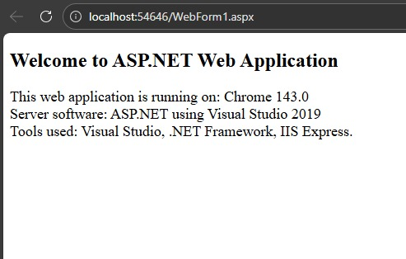

OUTPUT:
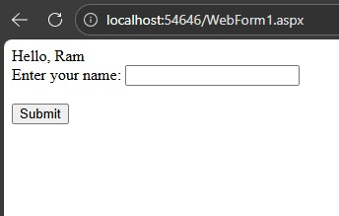

OUTPUT:
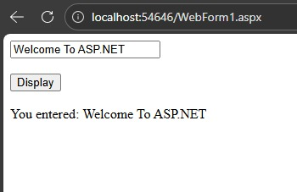
OUTPUT:
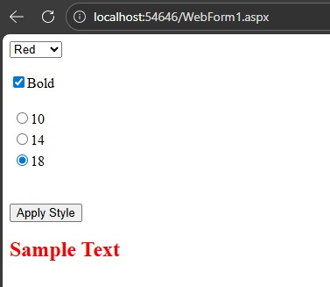
OUTPUT:
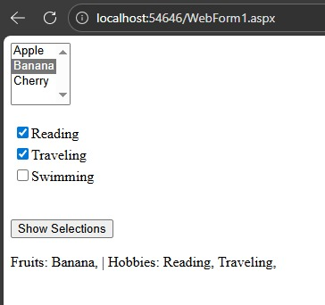
OUTPUT:
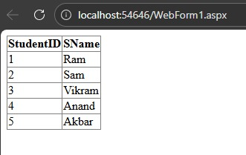
OUTPUT:
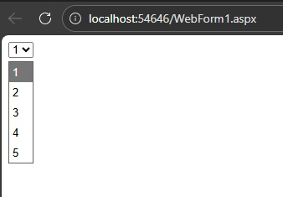

OUTPUT:
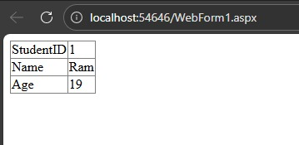

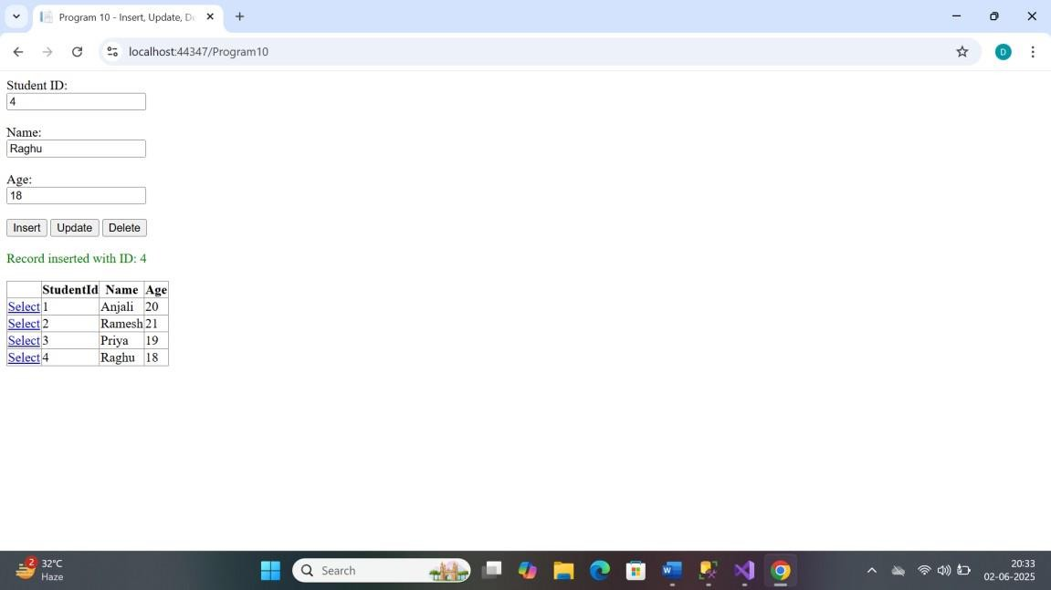
OUTPUT:

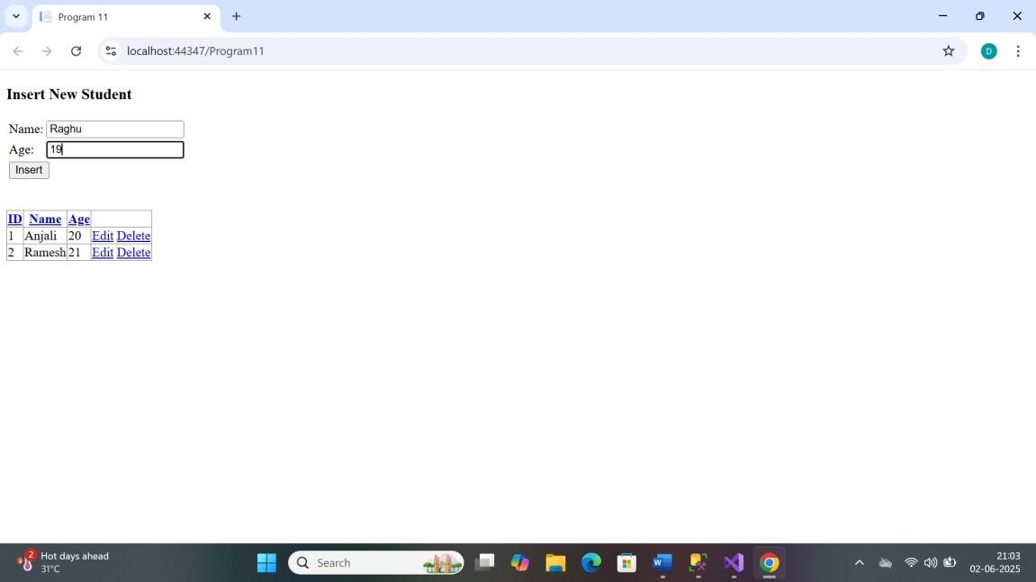
OUTPUT:

OUTPUT:
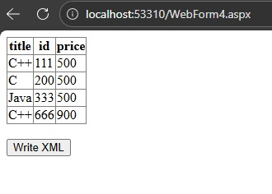
OUTPUT:
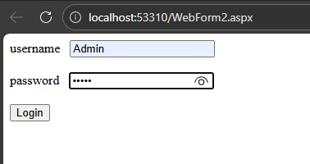
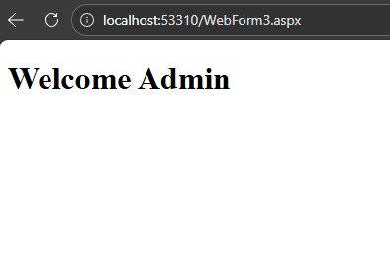

OUTPUT:
